CAPSTONE
BLE Source Security Assessment
Apply the Single Device Assessment Framework to an open-source BLE device

Target firmware: ____________________

Repository: ____________________

Methodology: Source-Code Static Analysis

Name: ___________________

Date: ___________________

1. Overview
In this assignment you take the role of a product security analyst. You will apply the Single Device Assessment Framework (SDAF) to the Bluetooth Low Energy (BLE) implementation of an open-source device firmware project you select and your instructor approves, and you will deliver a professional assessment report. A similar kind of document a consultant would hand a device manufacturer.
We used InfiniTime as the worked example, so your capstone applies the same method to a different target. The analysis is then genuinely your own, not a reproduction of the walkthrough. Choosing and scoping that target is part of the assessed skill.
This is not a worksheet. The deliverable is the work. A structured report that identifies where the firmware does and does not enforce security policy over BLE, characterizes each weakness with evidence and severity, and proposes concrete remediation using the capabilities the firmware's own BLE library already provides.

Learning objectives
- Apply the SDAF end to end. Intelligence gathering, framework application, and deliverable production to a real codebase.
- Read and reason about embedded C/C++ that defines BLE GATT services, GAP event handling, and pairing policy.
- Recognize missing authentication and weak negotiation patterns and map them to the right CWE identifiers.
- Justify severity with a defensible CVSS 3.1 vector, and map an attack path onto MITRE ATT&CK.
- Propose remediation grounded in the library's existing functions with the specific flags and calls that close each vulnerability

.

2. Scope & Rules of Engagement
This is a source-code static analysis engagement against the public source of your chosen target. You confirm behavior by reading source codes, characteristic definitions, configuration values, and event handlers. Then you cite findings at the file / function level rather than at a binary address.
Cite by file and function. Line numbers shift between versions, so cite by file and function and record the exact tag/commit you analyzed on the title page.

Engagement boundaries
In Scope | Out of Scope
BLE stack & GATT service definitions  Pairing, bonding & encryption configuration  Health / biometric data exposure over BLE  Firmware update (DFU) transport security  Device local filesystem service | Companion mobile / web apps  Cloud / backend systems  MCU hardware-level & side-channel attacks  Physical tamper / debug port (SWD) attacks  Live RF capture against devices you do not own

3. Choosing & Profiling Your Target
Pick one open-source BLE peripheral firmware project and get it approved. A good capstone target meets all of these:
- Open source, with readable C / C++
- A real GATT server: It defines services and characteristics (so there are permission flags to read).
- Some connection / pairing handling: a GAP event handler and a Security Manager configuration to examine.
- Not InfiniTime and not one you've already seen. The point is a fresh analysis.
- Small scope: a single device's firmware, not a whole SDK or OS.

Candidate categories
- An open-source wearable / fitness / sensor firmware with a BLE interface.
- It will be easier if you find firmware that uses the NimBLE library.

Profile your target (fill this in)
Project / device | ____________________________________
Repo + pinned tag / commit | ____________________________________
MCU / architecture | ____________________________________
BLE stack | NimBLE / Zephyr / other: ______________________
What data / actions cross BLE | ____________________________________

Where BLE security lives in firmware
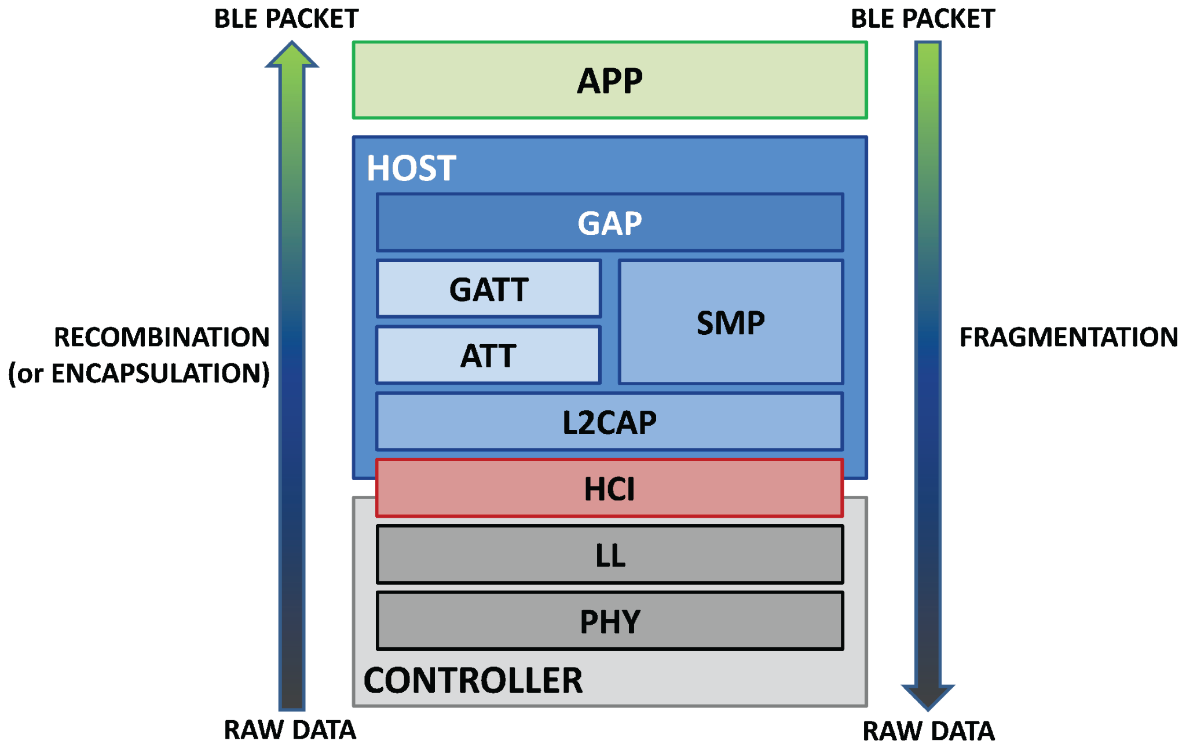
The BLE protocol stack. Your assessment targets policy decisions made at the application layer (top), which drives the host stack (GAP / GATT / ATT / SMP). Source: Y. Tawil, “BLE 101 Tutorial,” Atadiat, 2018 (see references).
The CONTROLLER (radio, link layer) and the lower HOST services come from the BLE library (NimBLE, Zephyr's stack, etc.). The security relevant decisions whether to require pairing, what I/O capability to advertise, which characteristics demand an encrypted or authenticated link are made above the library, in the firmware's own application code. That is where you focus.

Orientation: how to find the policy in any BLE codebase
This is the same reading you practiced in Modules 2–3, now on an unfamiliar tree. What to grep for and read:
What to find | Where / how
GATT service & characteristic table | NimBLE: ble_gatt_svc_def / ble_gatt_chr_def arrays and their .flags. Zephyr: BT_GATT_SERVICE / BT_GATT_CHARACTERISTIC with BT_GATT_PERM_*. The flags say what link conditions a read/write requires.
Pairing / Security Manager config | NimBLE: ble_hs_cfg.sm_* (bonding, MITM, SC, I/O cap). Zephyr: bt_conn_auth_cb / security level. Requesting a setting is not the same as enforcing it.
Connection / GAP event handler | The function handling connect / pairing / encryption change events. Ask: on connect, does it ever require security or just accept and proceed?
The libraries | Read the stack headers to see the full set of security flags and calls the firmware could have used (your remediation will name these).

4. Your Task
Assess the BLE implementation of your chosen target. Determine where the firmware enforces security policy and where it does not. For every weakness you find, characterize it, prove it from source, rate its severity, and propose a remediation built from the BLE library's own primitives.
The brief is deliberately open, part of the skill is deciding where to look. The orientation in section 3 is your starting point. The policy lives in the application layer connection handler and in the per characteristic flags. Follow a connection from the moment a peer arrives to the moment it reads data, and ask at each step, what, if anything, is required of the peer here?

5. Required Deliverable
Submit a single SDAF assessment report containing the sections below. A blank template mirroring this structure is provided separately; you may use it or reproduce the structure yourself.

SDAF Phase | Must contain
Phase 1 — Intelligence Gathering | Reconnaissance (device/stack profile), acquisition method, a security relevant configuration summary, and a static analysis register listing each insecure pattern with its file/function location and CWE.
Phase 2 — Framework Application | Analysis across the four SDAF lenses: Attack Surface, Access Control, Data Security, and Device Integrity. State what is exposed, what (if anything) gates it, and what data is accessible.
Phase 3 — Deliverable Production | A findings register: a detailed finding card per issue (title, category, CWE, CVSS 3.1 vector + score, source evidence, blast radius, remediation), an ATT&CK chain mapping the worst case path, and a remediation prioritization table.

Minimum bar
- At least three distinct findings, each supported by source evidence cited at the file/function level. (If your approved target proves genuinely well secured, document that posture with evidence a sound device is a valid result. Sometimes security assessments validate!)
- A defensible CVSS 3.1 vector string for every finding. Be ready to justify each metric.
- A remediation for every finding expressed in concrete library terms (the specific flag, call, or handler branch in your target's BLE stack), plus a note on which fixes share a root cause.

6. Grading Rubric (100 points)
Criterion | Pts | What earns full marks
Framework application | 20 | All three SDAF phases present and used correctly, not just filled in.
Evidence quality | 25 | Each claim tied to the right file/function. Code is read correctly, no asserted but unproven findings.
Finding accuracy | 20 | Correct CWE, sound vulnerability reasoning, no false positives or invented behavior.
Severity justification | 15 | CVSS vectors are defensible metric by metric and consistent with the described impact.
Remediation | 10 | Specific, source grounded fixes using the target library's capabilities, and root cause issues noted.
Professional writing | 10 | Clear, well-structured report a manufacturer could act on.

Bonus: chain two or more findings into a single attacker path and map it onto MITRE ATT&CK tactics/techniques.

Submission
Submit as a single PDF named LastName_SDAF_Capstone.pdf. Note your target project and the exact branch you analyzed on the title page.

Figure credits
- BLE protocol stack (§3) — Y. Tawil, Atadiat, 2018.
- BLE pairing phases (§4) — Nordic Semiconductor DevAcademy, BLE Fundamentals, Lesson 5.

